|  |  |
| --- | --- |
| ***Volume***  *10*  ***Issue***  *4*  ***\*Corresponding author*** *corr.author@xyz.ac.mm*  ***Submitted*** *4 May 2020*  ***Accepted*** *15 Sept 2020*  ***Published*** *30 Sept 2020*  ***Citation***  ***FIRST, A.; SECOND, B.***  *Article Title. Coleção Estudos Cariocas, v. 10, n. 4, 2020.*  ***The article was originally submitted in [LANGUAGE]. Translations into other languages were reviewed and validated by the authors and the editorial team. Nevertheless, for the Most accurate representation of the subject matter, readers are encouraged to consult the article in its original language.***    ***[A grey and black sign with a person in a circle  Description automatically generated](https://creativecommons.org/licenses/by/4.0/)*** | **Article Title**  ***Título do Artigo***  ***Título del Artículo***  First Author1*, Second Author2, and Third Author3 (more authors…)  1Affiliation of first author: Institution, address, ORCID, e-mail  2Affiliation of second author: Institution, address, ORCID, e-mail  3Affiliation of third author: Institution, address, ORCID, e-mail  Do not add author infromation, nor edit the left sidebar, when submitting. Abstract Please provide an abstract of no more than 100 words. Your abstract should explain the main contributions of your article, and should not contain any material that is not included in the main text.  Keywords: Keyword1, Keyword2, Keyword3 Resumo Por favor, forneça um resumo com no máximo 100 palavras. Seu resumo deve explicar as principais contribuições do seu artigo e não deve conter nenhum material que não esteja incluído no texto principal.  Palavras-chave: Palavra1, Palavra2, Palavra3 Resumen Por favor, escribe un resumen de no más de 100 palabras. Tu resumen debe explicar las principales contribuciones de tu artículo y no debe contener material que no esté incluido en el texto principal.  Palabras clave: Palabra1, Palabra2, Palabra3 |

# Introduction

Your introduction goes here! Some examples of commonly used commands and features are listed below, to help you get started.

* 1. **Introduction Subsection**

Here is an example of a subsection for the introductory section.

1. **Example of a Second Section**

Our format is not fixed, given the array of topics. Here is an example of a second section, which could be a literature review, materials and methods or whatever is appropriate to the research.

* 1. **Some Examples**

Use section and subsection commands to organize your document, e.g. subsection 2.1, Equation 1, Figure 1, Table 1.

* 1. **Figures and Tables**

Here are some examples for figures and tables. Figure 1 shows how to correctly place an image. Whenever possible, it should be 14.5 cm wide, so it fills the whole space assigned to it. Table 1 is a basic table, while Table 2 shows a larger example with table notes.

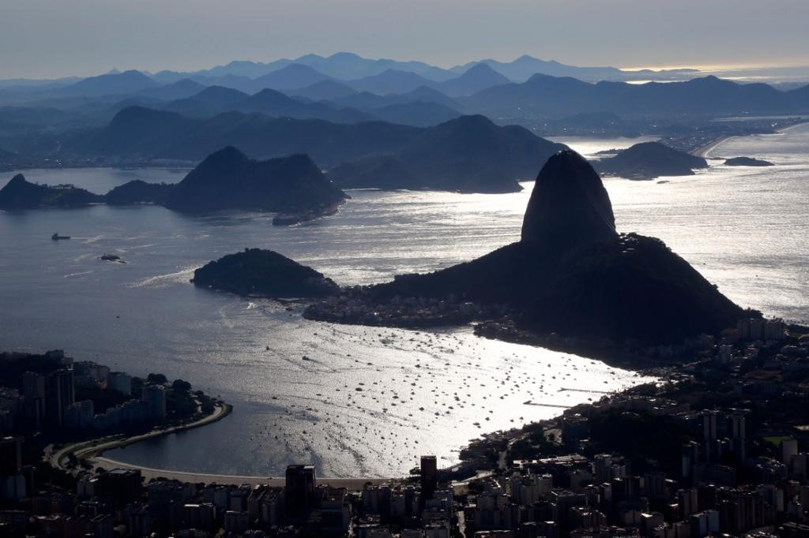Figure 1: An example image of Rio de Janeiro.

Source: Instituto Pereira Passos

* 1. **Citations**

Citations and references should be formatted using the ABNT style, like: Carmona (2021), Brasil (2000) or Martinelli et al. (2018), and, after a longer reference, include it in parentheses (GRIWODZ et al., 2021).

At the end of the article, all references must be listed in alphabetical order.

Table 1: An example table

|  |  |
| --- | --- |
| Item | Quantity |
| Educational sets | 4 |
| Meals | ? |

Source: Instituto Pereira Passos

Table 2: An example table with tablenotes

|  |  |  |  |  |
| --- | --- | --- | --- | --- |
| Neighborhood | Population(*n*) | Density | Index | Result |
| Grajaú | 62570 | 581 | 114 | Passed |
| Vila Isabel | 105983 | 61 | 213 | Passed |
| Del Castilho | 87992 | 44 | 111 | Passed |
| Jardim Guanabara | 21093 | 52 | 892 | Passed |

1here's a note

2and another

Source: Instituto Pereira Passos

Longer citations must follow this format:

Quam suscipit ut quidem et animi numquam consectetur et. Nihil et commodi ut officia eveniet beatae qui. Placeat accusantium eius consequatur animi nisi sed. Pariatur et dolores tempore velit similique voluptatem similique error. Quam suscipit ut quidem et animi numquam consectetur et. Nihil et commodi ut officia eveniet beatae qui. Placeat accusantium eius consequatur animi nisi sed. Quam suscipit ut quidem et animi numquam consectetur et. Nihil et commodi ut officia eveniet beatae qui. Quam suscipit ut quidem et animi numquam consectetur et. Nihil et commodi ut officia eveniet beatae qui.

* 1. **Mathematics**

Equations must be centralized and referenced by numbers. Use the appropriate tool available. Here’s an example:

Let $X_{1},X_{2},…,X_{n}$ be a sequence of independent and identically random variables with $E\left[X_{i}\right]=μ$ and ${Var[X}_{i}]=σ^{2}<∞$, and let

$S_{n}=\frac{X_{1}+X_{2}+…+X_{n}}{n}=\frac{1}{n}\sum_{i}^{n}{X_{i}}$ (1)

Denote their mean. Then, as $n$ approaches infinity, the random variables $\sqrt{n}(S_{n}-μ)$ converge in distribution to a normal .

* 1. **Lists**

You can make lists with automatic numbering …

1. Like this,
2. and like this.

… or bullet points …

* Like this,
* and like this.

… or with words and descriptions …

**Word** Definition

**Concept** Explanation

**Idea** Text

1. **Example of a Third Section**

Quam suscipit ut quidem et animi numquam consectetur et. Nihil et commodi ut officia eveniet beatae qui. Placeat accusantium eius consequatur animi nisi sed. Pariatur et dolores tempore velit similique voluptatem similique error.

Quam suscipit ut quidem et animi numquam consectetur et. Nihil et commodi ut officia eveniet beatae qui. Placeat accusantium eius consequatur animi nisi sed. Pariatur et dolores tempore velit similique voluptatem similique error. Quam suscipit ut quidem et animi numquam consectetur et. Nihil et commodi ut officia eveniet beatae qui. Placeat accusantium eius consequatur animi nisi sed. Pariatur et dolores tempore velit similique voluptatem similique error.

1. **Example of a Fourth Section**

Quam suscipit ut quidem et animi numquam consectetur et. Nihil et commodi ut officia eveniet beatae qui. Placeat accusantium eius consequatur animi nisi sed. Pariatur et dolores tempore velit similique voluptatem similique error.

Quam suscipit ut quidem et animi numquam consectetur et. Nihil et commodi ut officia eveniet beatae qui. Placeat accusantium eius consequatur animi nisi sed. Pariatur et dolores tempore velit similique voluptatem similique error. Quam suscipit ut quidem et animi numquam consectetur et. Nihil et commodi ut officia eveniet beatae qui. Placeat accusantium eius consequatur animi nisi sed.

1. **Conclusion**

Quam suscipit ut quidem et animi numquam consectetur et. Nihil et commodi ut officia eveniet beatae qui. Placeat accusantium eius consequatur animi nisi sed. Pariatur et dolores tempore velit similique voluptatem similique error.

Quam suscipit ut quidem et animi numquam consectetur et. Nihil et commodi ut officia eveniet beatae qui. Placeat accusantium eius consequatur animi nisi sed. Pariatur et dolores tempore velit similique voluptatem similique error. Quam suscipit ut quidem et animi numquam consectetur et. Nihil et commodi ut officia eveniet beatae qui. Placeat accusantium eius consequatur animi nisi sed.

**References**

Use the ABNT style.

BRASIL. **Lei Nº 9.985/2000.** Brasília, DF: [s.n.], 19 July 2000. Regulamenta o art. 225, § 1o, incisos I, II, III e VII da Constituição Federal, institui o Sistema Nacional de Unidades de Conservação da Natureza e dá outras providências. Available from: [<https://www.planalto.gov.br/ccivil_03/leis/l9985.htm>](https://www.planalto.gov.br/ccivil_03/leis/l9985.htm). Visited on: 15 Aug. 2024.

CARMONA, R. Bonifácio, gênese do pensamento nacional. **Tensões Mundiais**, v. 9, n. 16, p. 196–215, 2021. DOI: 10.33956/tensoesmundiais.v9i16.531. Available from: [<https://revistas.uece.br/index.php/tensoesmundiais/article/view/531>](https://revistas.uece.br/index.php/tensoesmundiais/article/view/531). Visited on: 13 Dec. 2024.

GRIWODZ, Carsten et al. AliceVision Meshroom: An open-source 3D reconstruction pipeline. In: PROCEEDINGS of the 12th ACM Multimedia Systems Conference - MMSys ’21. [S.l.]: ACM Press, 2021. DOI: 10.1145/3458305.3478443.

MARTINELLI, Gustavo et al. **Livro Vermelho da Flora Endêmica do Estado do Rio de Janeiro**. [S.l.]: CNCFlora, 2018. ISBN 978-85-88742-88-8. Available from: [<http://dspace.jbrj.gov.br/jspui/handle/doc/92>](http://dspace.jbrj.gov.br/jspui/handle/doc/92).

**About the Authors**

Author biographies come here. Change title to "About the Author" if there's only one. Fill in only after the article's acceptance.

Jane Doe is...

**Author Contributions**

Omit those that do not apply, for more than one author per topic, separate initials by commas. For example: J.M.M., L.C.F., X.Y.M. Fill in only after the article's acceptance.

Conceptualization, [insert initials]; methodology, [insert initials]; software [insert initials]; validation, [insert initials]; formal analysis, [insert initials]; investigation, [insert initials]; resources, [insert initials]; data curation, [insert initials]; writing—original draft preparation, [insert initials]; writing—review and editing [insert initials]; visualisation, [insert initials]; supervision, [insert initials]; project administration, [insert initials]; funding acquisition, [insert initials]. All authors have read and agreed to the published version of the manuscript.

**Funding**

Omit if the article has not been funded by any agency. Fill in only after the article's acceptance.

This research was financed by...

**Institutional Review**

Omit if the article has not been reviewed by any agency. Fill in only after the article's acceptance.

This research was approved by...

**Informed Consent**

Omit if the article did not need any informed consent by human subjects. Fill in only after the article's acceptance.

This research was approved by...

**Data Availability**

Omit if there is no data available to share. Fill in only after the article's acceptance.

Data for this research may be available...

**Acknowledgements**

Omit if there are no acknowledgements. Change to "The Author" if there's only one. Fill in only after the article's acceptance.

The authors acknowledge the contributions...

**Conflicts of Interest**

This section is mandatory; delete this paragraph and keep the sentence below. Change to "The Author" if there's only one. Fill in only after the article's acceptance.

The authors declare no conflicts of interest.

**About *Coleção Estudos Cariocas***

*Coleção Estudos Cariocas* (ISSN 1984-7203) is a publication dedicated to studies and research on the Municipality of Rio de Janeiro, affiliated with the Pereira Passos Institute (IPP) of the Rio de Janeiro City Hall.

Its objective is to disseminate technical and scientific production on topics related to the city of Rio de Janeiro, as well as its metropolitan connections and its role in regional, national, and international contexts. The collection is open to all researchers (whether municipal employees or not) and covers a wide range of fields — provided they partially or fully address the spatial scope of the city of Rio de Janeiro.

Articles must also align with the Institute’s objectives, which are:

1. to promote and coordinate public intervention in the city’s urban space;
2. to provide and integrate the activities of the city’s geographic, cartographic, monographic, and statistical information systems;
3. to support the establishment of basic guidelines for the city’s socioeconomic development.

Special emphasis will be given to the articulation of the articles with the city's economic development proposal. Thus, it is expected that the multidisciplinary articles submitted to the journal will address the urban development needs of Rio de Janeiro.